Required Practical Activity:
Determination of the reacting volumes of solutions of a strong acid and a strong alkali by titration.

Note:
This resource is designed as a review of the required practical activity, covering all possible skills that could be developed through the investigation. This resource can be adapted to suit the needs of your class, depending on which skills your class need support with.

In this experiment we will use a burette and colour-changing indicator to find the reacting volumes of solutions of a strong acid and alkali.
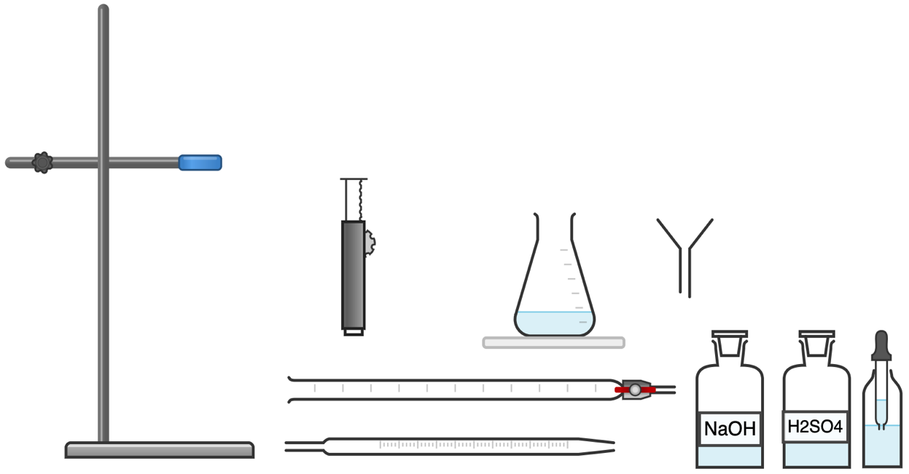
(Phenolphthalein)
Equipment Per Group

- Variables
- What is the independent variable?
- What is the dependent variable?
- What are suitable control variables?
- Equipment:
- What measurements need to be taken in this investigation?
- What is the most suitable piece of apparatus to take these measurements with? Why?
- Identify any hazards in this investigation.
- How can we minimise these hazards?
- Why is it important to remove the funnel from the burette before carrying out the titration?
- How do you read the scale of the burette?
- Why do we read the burette in this way?
- Why do we constantly swirl the conical flask?
- Why do we use a white tile beneath the conical flask?
- Why do we add the solution from the burette slowly?
- What colour change does the phenolphthalein indicator exhibit?

4. Results
Attempt | Volume of sulfuric acid added to neutralise the 0.1 mol/dm³ sodium hydroxide (cm³)
1 | 16.3
2 | 15.7
3 | 15.5
Mean (from concordant results) | 15.6

- Why do we run numerous titrations and take the mean result?
- Why is the first result most likely to be inaccurate?
- Why do we only calculate the mean from concordant results?
- What was the mean volume of sulfuric acid added to neutralise the sodium hydroxide?
- What is the balanced equation for this reaction?
- What is the mole ratio of NaOH:H₂SO₄?
- Calculate the concentration of the sulfuric acid.

